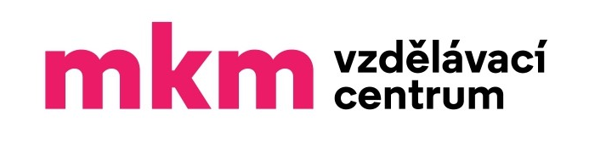
Vzdělávací centrum MKM
WSET® Level 1/ Level 2/ Level 3 Award in Wines - Booking Form
Please ensure that you read the Terms and conditions and complete all sections on the booking form where applicable. Email the completed form to: info@mkm.cz

SECTION 1 - YOUR DETAILS

First Name:
Surname:
Postal Address: _________________________________________________________________________________
Date of Birth:
Telephone No.:
Email Address:

Invoice details:
(Company) name:
Address:
IČO / (C)IN:
Have you studied WSET courses before?_______________________________________
Your details may be used by us to keep you informed of the course on which you have registered.
We never pass our customer’s details to other parties.
We send information by email, so please ensure you have entered your email address.

SECTION 2 - THE COURSE
I wish to apply for a place on the following course - please tick the chosen course:
WSET® Level 1 Award in Wines _____________
WSET® Level 2 Award in Wines _____________
WSET® Level 3 Award in Wines _____________
NB: Study materials and examination fees are INCLUDED in course fees (according to Terms and conditions).
Course Start Date / Place: ……………………………………...
NB: Please read the Course Specifications before enrolling on the relevant course.
Level 1: https://www.wsetglobal.com/media/11682/wset_l1wines_spec_en_jun2022_issue12.pdf
Level 2: https://www.wsetglobal.com/media/13167/wset_l2wines_specification_en_may2023_issue2.pdf
Level 3: https://www.wsetglobal.com/media/11731/wset_l3wines_specification_en_highres_may2022_issue2.pdf

SECTION 3 – TERMS AND CONDITIONS
ENG - https://www.vzdelavaci-centrum-mkm.com/terms-and-conditions
CZE - https://www.vzdelavaci-centrum-mkm.com/obchodn%C3%AD-podm%C3%ADnky-terms-and-conditions

SECTION 4 - MARKETING INFORMATION
Please state how you came to hear about WSET courses and Vzdělávací centrum MKM s.r.o.:

SECTION 5 - STUDENTS DECLARATION
I have read and understood the Terms and conditions. I understand that all courses are subject to minimum numbers and Vzdělávací centrum MKM s.r.o. reserves the right to reschedule, cancel, close or combine courses if necessary. I understand that I am required to present authorised photographic identification at all examinations and may be refused entry to an examination if not produced.

I agree to the processing of personal data.
(Souhlasím se zpracováním osobních údajů.)
I agree to the taking of photographs and videos during the courses.
(Souhlasím s pořizováním fotografií a videí během kurzů.)
I agree to receiving newsletters and offers related to the activities of the Vzdělávací centrum MKM s.r.o. .
(Souhlasím se zasíláním newsletterů a nabídek souvisejících s činností Vzdělávacího centra MKM s.r.o.)
I agree to the Terms and conditions.
(Souhlasím s obchodními podmínkami.)

Signature______________________________________ Date________________________________________
Vzdělávací centrum MKM s.r.o. Email: info@mkm.cz
Jakubská 121/1 Phone: +420702178192
602 00 Brno
CZECH REPUBLIC

